## INTEGRATION OF TDM & SV

The following points explain the **information** flow that is shown in the illustration:

1. Register a file object to the CA TDM Portal.   
   For SV integration, the file object must be of type WSDL, XML RR pair, JSON RR pair, or REST RR pair.
2. Create **and** **register derived objects** in the target database based on the registered file object.
3. **Import** the sample RR pair data into the derived objects.
4. **Define** **data generation rules**.  
   This step adds data generation rules to the derived objects, which help during the process of data generation.
5. **Publish** the data into **derived objects**.  
   This step adds more data to the derived objects.
6. Export the **generated data** (as RR pair files) into a virtual service in **CA Service Virtualization**.

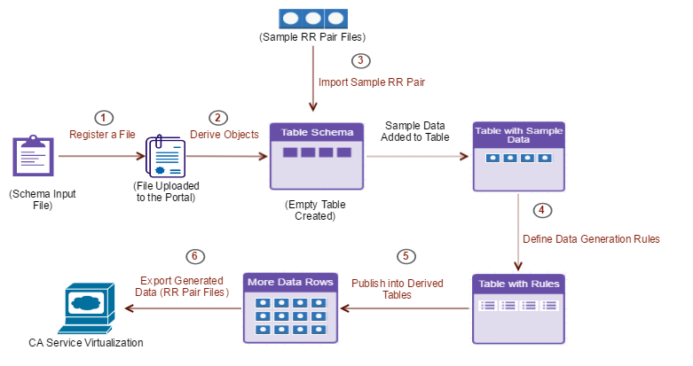

**Scenario:** Get **Supplier Information** Based on a **ZIP Code**. In this scenario we **virtualize** a service to get details **about** the supplier based on a ZIP code. In these XML RR pairs, the **request XML file** must include the **ZIP code information** and the corresponding **response XML file** must include the related **supplier information**. We generate **multiple** similar XML files, adhering to the same schema defined in the associated **WSDL file**. All the XML RR pairs are then hosted in **the virtual service**.

Steps to be followed:

1. Create a Database in SQL Server.
2. [Create a Portal Project](https://docops.ca.com/ca-test-data-manager/4-1/en/provisioning-test-data/data-discovery/data-discovery-using-the-ca-tdm-portal/prepare-test-data-for-non-relational-data-sources/xsd-xml-wsdl-json-rr-pair-file-types/integration-with-ca-service-virtualization#IntegrationwithCAServiceVirtualization-CreateaPortalProject).
3. [Create a Connection Profile](https://docops.ca.com/ca-test-data-manager/4-1/en/provisioning-test-data/data-discovery/data-discovery-using-the-ca-tdm-portal/prepare-test-data-for-non-relational-data-sources/xsd-xml-wsdl-json-rr-pair-file-types/integration-with-ca-service-virtualization#IntegrationwithCAServiceVirtualization-CreateaConnectionProfile).
4. [Register a File Object (WSDL)](https://docops.ca.com/ca-test-data-manager/4-1/en/provisioning-test-data/data-discovery/data-discovery-using-the-ca-tdm-portal/prepare-test-data-for-non-relational-data-sources/xsd-xml-wsdl-json-rr-pair-file-types/integration-with-ca-service-virtualization#IntegrationwithCAServiceVirtualization-RegisteraFileObject(WSDL)).
5. [Create and Register Derived Objects](https://docops.ca.com/ca-test-data-manager/4-1/en/provisioning-test-data/data-discovery/data-discovery-using-the-ca-tdm-portal/prepare-test-data-for-non-relational-data-sources/xsd-xml-wsdl-json-rr-pair-file-types/integration-with-ca-service-virtualization#IntegrationwithCAServiceVirtualization-CreateandRegisterDerivedObjects).
6. [**Create** a Data Generator](https://docops.ca.com/ca-test-data-manager/4-1/en/provisioning-test-data/data-discovery/data-discovery-using-the-ca-tdm-portal/prepare-test-data-for-non-relational-data-sources/xsd-xml-wsdl-json-rr-pair-file-types/integration-with-ca-service-virtualization#IntegrationwithCAServiceVirtualization-CreateaDataGenerator).
7. [Import the Sample RR Pairs into Derived Objects](https://docops.ca.com/ca-test-data-manager/4-1/en/provisioning-test-data/data-discovery/data-discovery-using-the-ca-tdm-portal/prepare-test-data-for-non-relational-data-sources/xsd-xml-wsdl-json-rr-pair-file-types/integration-with-ca-service-virtualization#IntegrationwithCAServiceVirtualization-ImporttheSampleRRPairsintoDerivedObjects).
8. [Verify Records in the Database After Import](https://docops.ca.com/ca-test-data-manager/4-1/en/provisioning-test-data/data-discovery/data-discovery-using-the-ca-tdm-portal/prepare-test-data-for-non-relational-data-sources/xsd-xml-wsdl-json-rr-pair-file-types/integration-with-ca-service-virtualization#IntegrationwithCAServiceVirtualization-VerifyRecordsintheDatabaseAfterImport).
9. [Add Data Generation Rules](https://docops.ca.com/ca-test-data-manager/4-1/en/provisioning-test-data/data-discovery/data-discovery-using-the-ca-tdm-portal/prepare-test-data-for-non-relational-data-sources/xsd-xml-wsdl-json-rr-pair-file-types/integration-with-ca-service-virtualization#IntegrationwithCAServiceVirtualization-AddDataGenerationRules).
10. [Publish More Data into Derived Objects](https://docops.ca.com/ca-test-data-manager/4-1/en/provisioning-test-data/data-discovery/data-discovery-using-the-ca-tdm-portal/prepare-test-data-for-non-relational-data-sources/xsd-xml-wsdl-json-rr-pair-file-types/integration-with-ca-service-virtualization#IntegrationwithCAServiceVirtualization-PublishMoreDataintoDerivedObjects).
11. [Verify Extra Records in the Database After Publishing](https://docops.ca.com/ca-test-data-manager/4-1/en/provisioning-test-data/data-discovery/data-discovery-using-the-ca-tdm-portal/prepare-test-data-for-non-relational-data-sources/xsd-xml-wsdl-json-rr-pair-file-types/integration-with-ca-service-virtualization#IntegrationwithCAServiceVirtualization-VerifyExtraRecordsintheDatabaseAfterPublishing).
12. [Create a Virtual Service in CA Service Virtualization](https://docops.ca.com/ca-test-data-manager/4-1/en/provisioning-test-data/data-discovery/data-discovery-using-the-ca-tdm-portal/prepare-test-data-for-non-relational-data-sources/xsd-xml-wsdl-json-rr-pair-file-types/integration-with-ca-service-virtualization#IntegrationwithCAServiceVirtualization-CreateaVirtualServiceinCAServiceVirtualization).
13. [Configure the Virtual Service Connection in the CA TDM Portal](https://docops.ca.com/ca-test-data-manager/4-1/en/provisioning-test-data/data-discovery/data-discovery-using-the-ca-tdm-portal/prepare-test-data-for-non-relational-data-sources/xsd-xml-wsdl-json-rr-pair-file-types/integration-with-ca-service-virtualization#IntegrationwithCAServiceVirtualization-ConfiguretheVirtualServiceConnectioninthePortal).
14. [Export the Generated Data (RR Pairs) into the Virtual Service](https://docops.ca.com/ca-test-data-manager/4-1/en/provisioning-test-data/data-discovery/data-discovery-using-the-ca-tdm-portal/prepare-test-data-for-non-relational-data-sources/xsd-xml-wsdl-json-rr-pair-file-types/integration-with-ca-service-virtualization#IntegrationwithCAServiceVirtualization-ExporttheGeneratedData(RRPairs)intotheVirtualService).
15. [Verify the RR Pairs Added to the Virtual Service](https://docops.ca.com/ca-test-data-manager/4-1/en/provisioning-test-data/data-discovery/data-discovery-using-the-ca-tdm-portal/prepare-test-data-for-non-relational-data-sources/xsd-xml-wsdl-json-rr-pair-file-types/integration-with-ca-service-virtualization#IntegrationwithCAServiceVirtualization-VerifytheRRPairsAddedtotheVirtualService).

**Step 1 : Create a DB in SQL SERVER**

1. Launch **SQL Server Management studio** with valid credentials.
2. Expand **Object explorer**, right click **database** and select **new database**.
3. Enter the **DB name**.

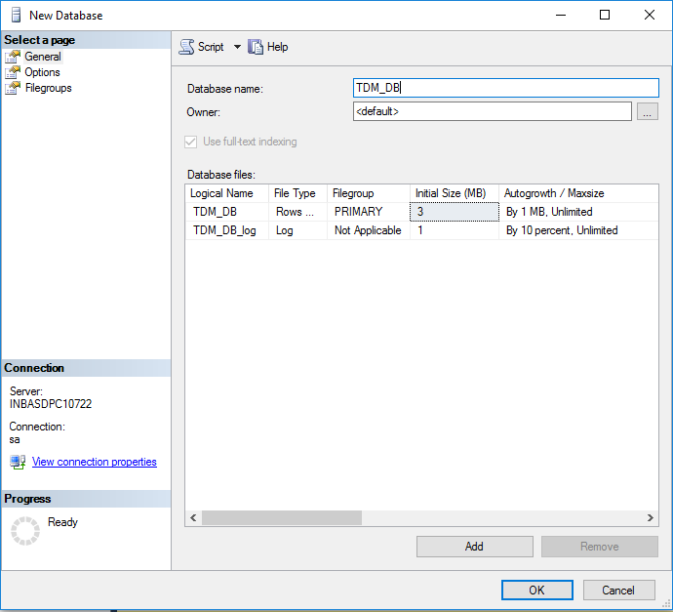

**Step 2 : Create a Portal Project**

1. Access the CA TDM Portal.
2. Select the **Project Manager** icon (gear icon).
3. Click **New Project**.
4. Enter information in the following fields for this example:
   * **Name:** Name of the CA TDM Portal project.
   * **Description:** Description of the project.
   * **Version:** Project version.
   * **Version Description:** Project version description.
5. Click **Save**.

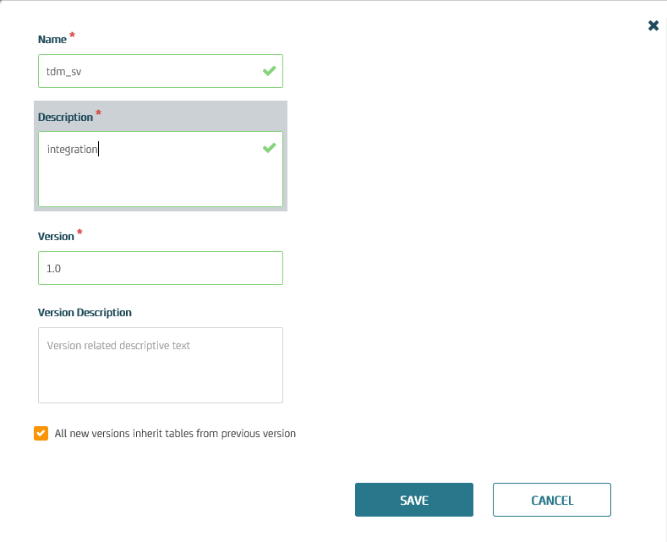

**Step 3 :** [**Create a Connection Profile**](https://docops.ca.com/ca-test-data-manager/4-1/en/provisioning-test-data/data-discovery/data-discovery-using-the-ca-tdm-portal/prepare-test-data-for-non-relational-data-sources/xsd-xml-wsdl-json-rr-pair-file-types/integration-with-ca-service-virtualization#IntegrationwithCAServiceVirtualization-CreateaConnectionProfile)**.**

1. Access the **CA TDM Portal**.
2. Click **Configuration** in the left pane.
3. Click the **Connection Profiles** option.
4. Click the **New Profile** button.
5. Enter information in the following fields for this example:
   * **Profile Name:** Specify the profile name.
   * **Description:** Specify the connection description.
   * **DBMS:** SQL SERVER.
   * **Server:** Specify the server where the Microsoft SQL Server database is available.
   * **Database:** Name of the Database.
   * **Port:** 1433
   * **User Name:** sa.
   * **Password:** Password123.
6. Click **Test** to verify the connection. Click **Save**.

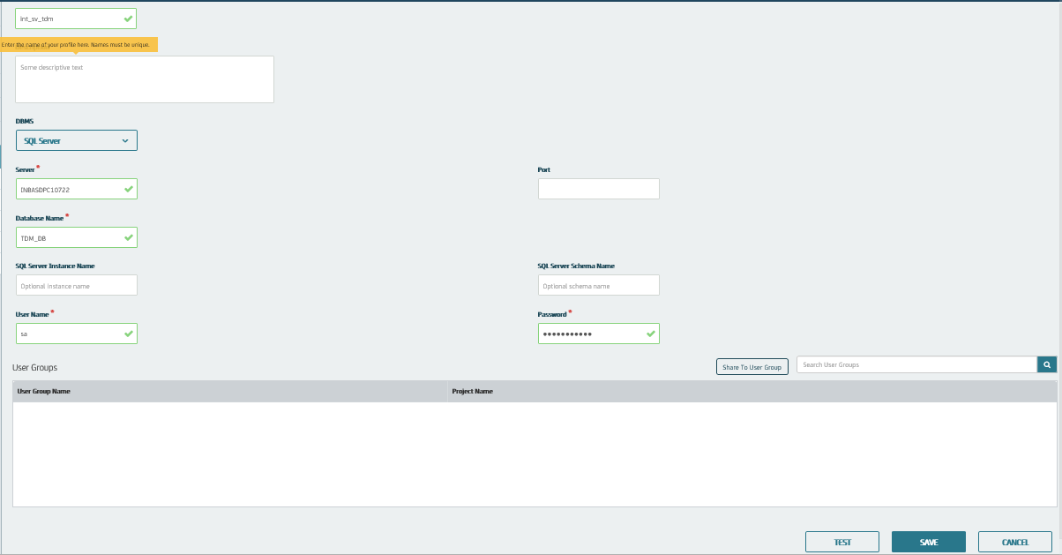

### **Step 4 : Register a File Object (WSDL)**

1. Select the appropriate **project** and its **version** from the **Project** list.
2. Click **Modeling** and then click **Objects**.
3. Click **Register New** **Object(s)**.
4. Select **WSDL** from the **Object Type**. Enter the object name in the **Name** **field**
5. Drag and drop the **WSDL** **file**. Click **Save** to **register** the WSDL file object.

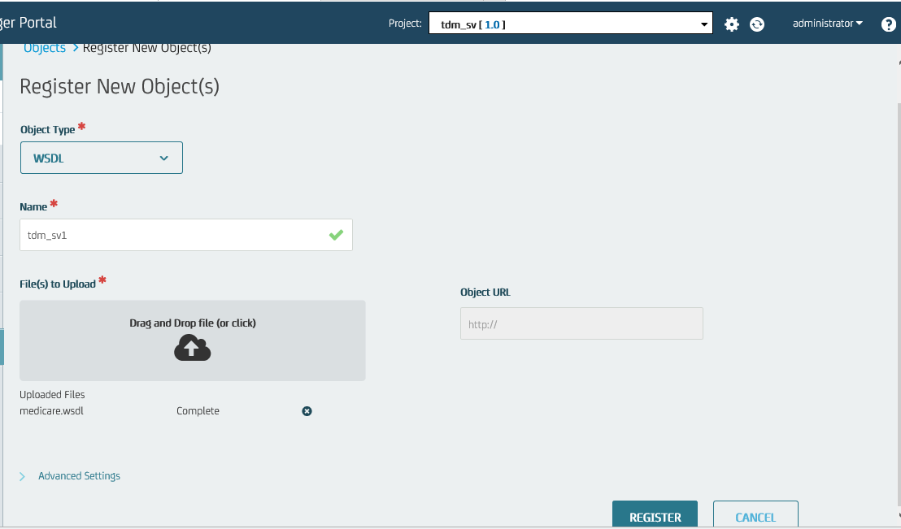

### **Step 5 : Create and Register Derived Objects**

When you create and register derived objects, schema is added to the **relational database** based on the registered WSDL file.

1. Click **Objects.** Select the object created.
2. Click the WSDL operation **GetSupplierByZipCode** in the table that lists the available WSDL operations for the registered WSDL file.
3. Select the appropriate **connection profile**.
4. Click the **Create** **and Register** button.

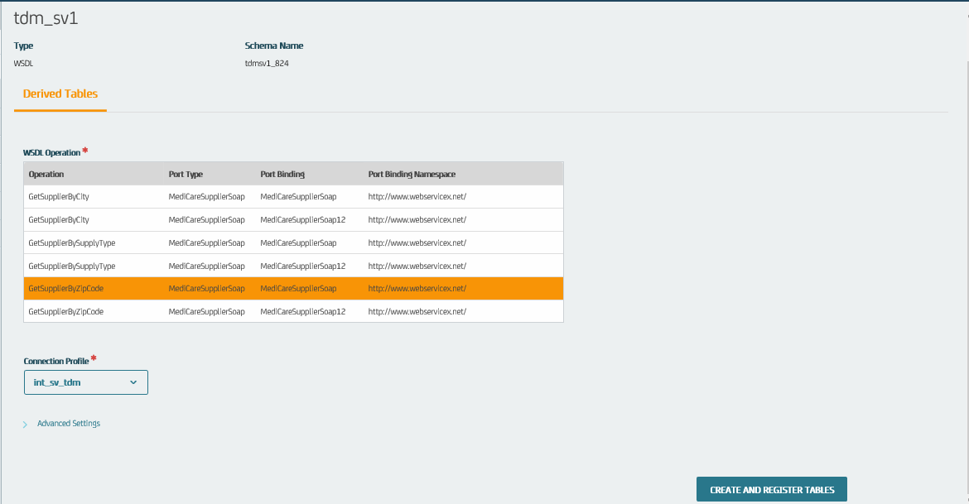

### **Step 6 : Create a Data Generator**

Create a data generator for your project.

1. Click **Generators** **>>** **New Generator** button.
2. Enter information in the following fields for this example:

* **Name:** Specify the data generator name.
* **Description:** Specify the data generator description.

1. **Click** **Save**.

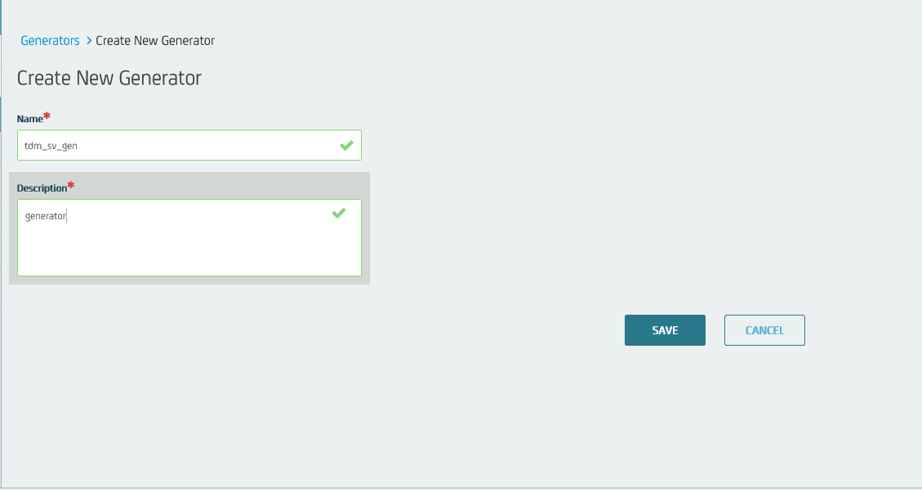

### **Step 7 : Import the Sample RR Pairs into Derived Objects**

**Import** the sample data (XML RR pairs) into the **data** **generator** and into the **target** **database**.

1. Click **Objects**. Select the object created.
2. Click the **Import** **Data** icon.

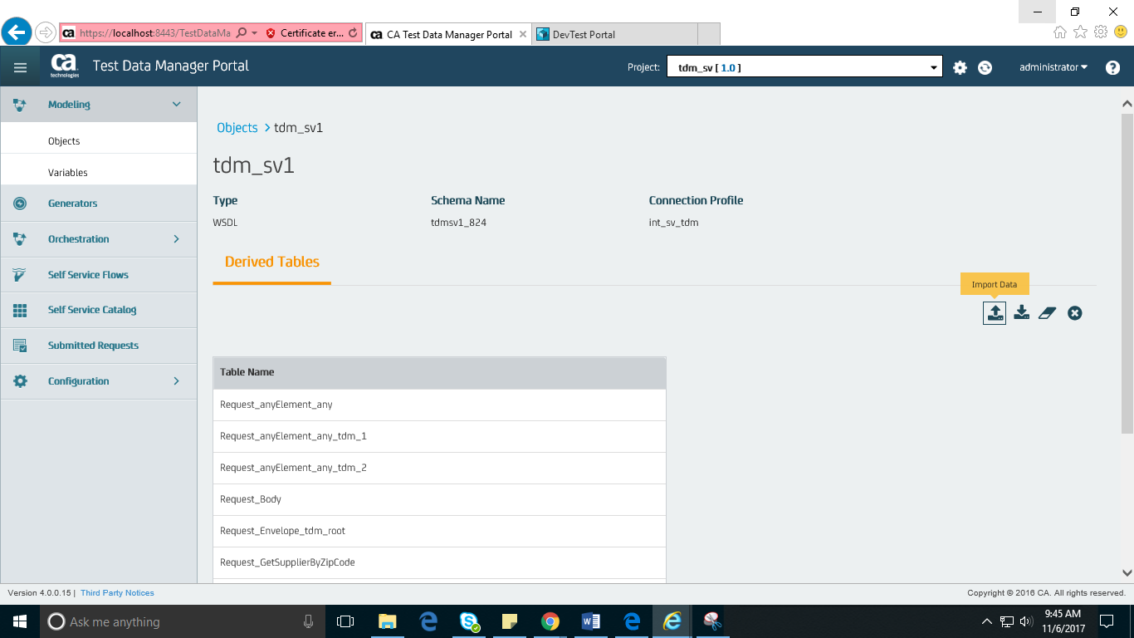

1. Enter information in the following fields:
   * **R**/**R Pair Link ID:** Specify the RR pair link ID.
   * **Advanced** **Settings**: Specify the connection profile and the schema name
   * **Request-File to Upload**: XML request file.
   * **Response-File to Upload**: XML response file
   * **Import to Generator**: Select this option.
   * **Data Generator Connection**: Specify the data generator.
2. Click the **Import** button.

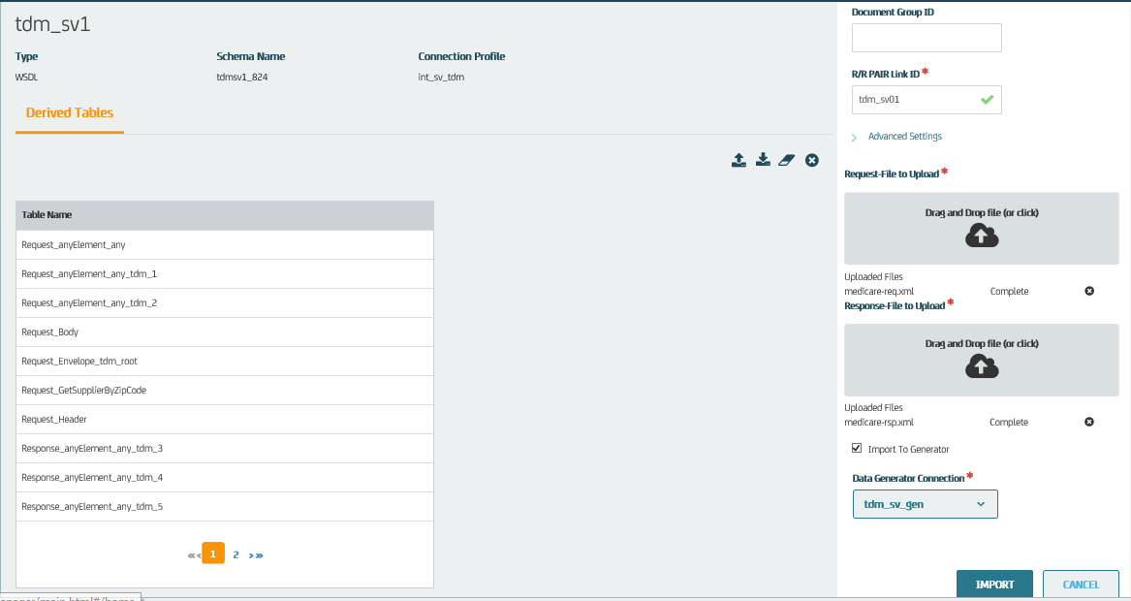

### **Step 8 : Verify Records in the Database After Import**

Access the **Microsoft** **SQL** **Server** **database** to verify that the **sample** **data** is added to the **derived** **objects** in the **database**. The derived object includes only **one** **record**, with the **ZIP** **code** as **60532.**

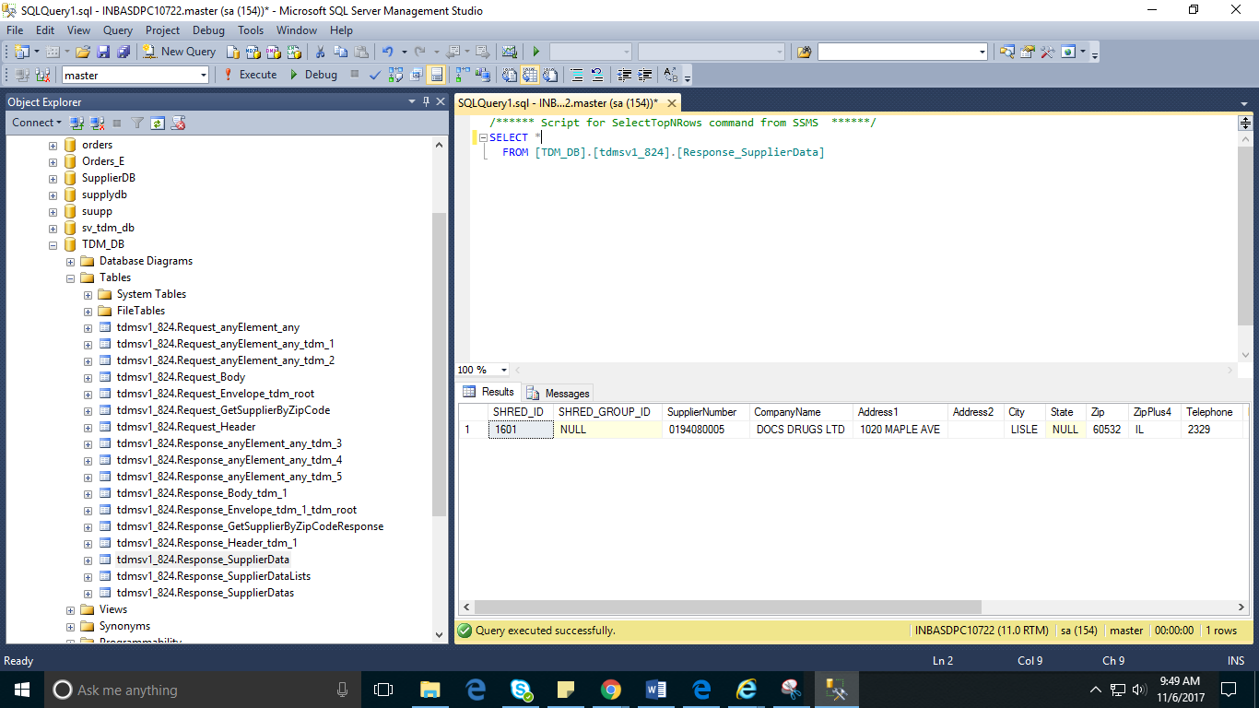

### **Step 9 : Add Data Generation Rules**

These rules help you add **more** **data** to your **derived** **objects** during the **data** **publishing**

1. Click **Generators**. Select data generator that is created.
2. Click the **Select Tables** **button** to open the **Registered Tables** dialog.
3. Click the **Relational Edit** **button**.
4. Select the **Make** **All** **Children** **References** and **Make** **All** **Parents** **default options**, and click **OK**.
5. Review the information in the **Relational Editor Results** dialog, and click **OK**.

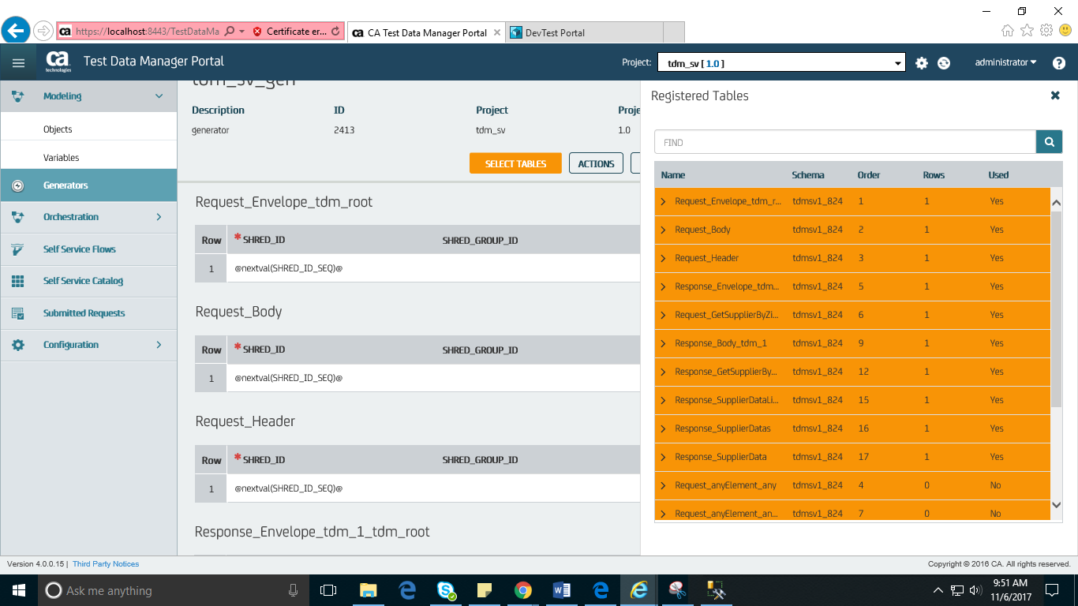

1. Add data generation rules for **Request_GetSupplierByZipCode**:

**Zip**: @randlov (0,@**seedlist**(US Zip-Codes)@)@

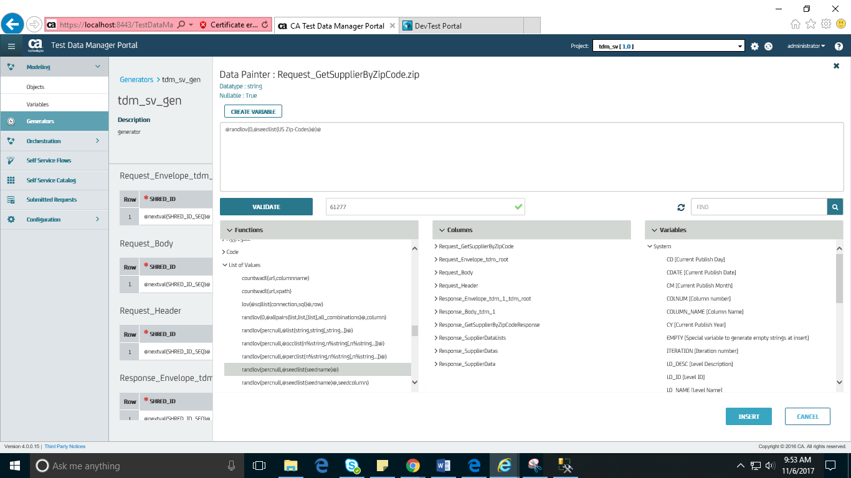

1. Add **data generation rules** to the appropriate cells of all the required derived objects.   
   Data generation rules added to the **Response_SupplierData** derived object are as follows:
   * **SHRED_ID:** @nextval(SHRED_ID_SEQ)@
   * **SupplierNumber:** @randlov(0, @seedlist(Car Parts)@)@
   * **CompanyName:** @randlov(0, @seedlist(Companies)@)@ LTD
   * **Address1:** @randlov(0,@seedlist(US Address Line 1)@,1)@
   * **City:** @randlov(0,@seedlist(US City State Zip County)@,1)@
   * **Zip:** ^Request_GetSupplierByZipCode.zip(1)^
   * **ZipPlus4:** @randlov(0,@seedlist(US City State Zip County)@,2)@
   * **Telephone:** @randrange(2300,9800)@
   * **Description:** (@randrange(110,999)@)@randrange(110,999)@-@randrange(1110,1999)@
   * **Response_SupplierDatas_SHRED_ID:** ^Response_SupplierDatas.SHRED_ID(1)^

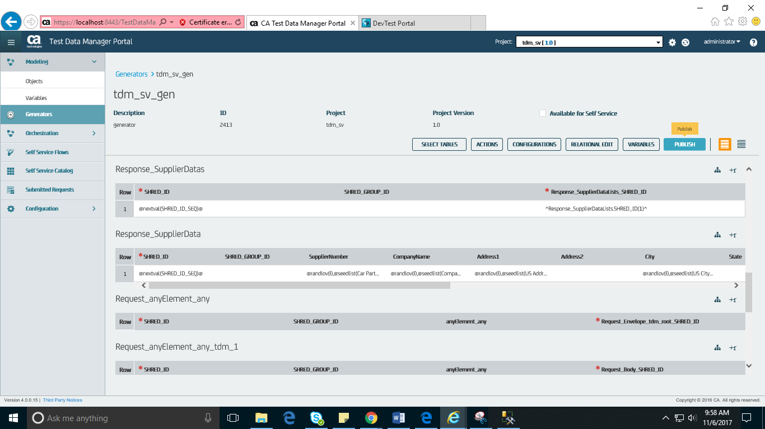

### **Step 10 : Publish More Data into Derived Objects**

1. Click the **data generator** created.
2. Click the **Select** **Tables** button to open the **Registered Tables** dialog.
3. Click the **rows** corresponding to the used **derived** **objects** that you want to use for the **data** **publishing**.
4. Review the **data** **generation** rules (added to the derived objects in the preceding procedure).
5. Click the **Publish** **button**.
6. Enter information in the following fields for this example:
   1. **Table Count:** Specify the table count value.
   2. **Publish to: Sp**ecify the connection profile.
   3. **Schema:** Specify the target schema name
   4. **Repeat:** Specify the value to provide the number of rows to add to the derived objects.
   5. **Email:** Specify the email ID where you want to send the publishing notifications.
   6. **Schedule** **Publish**: Select Now.
   7. **Include** in **Publish**: Select the check box that is available before the table name to include the table in the publish.
7. Click the **Publish** button.

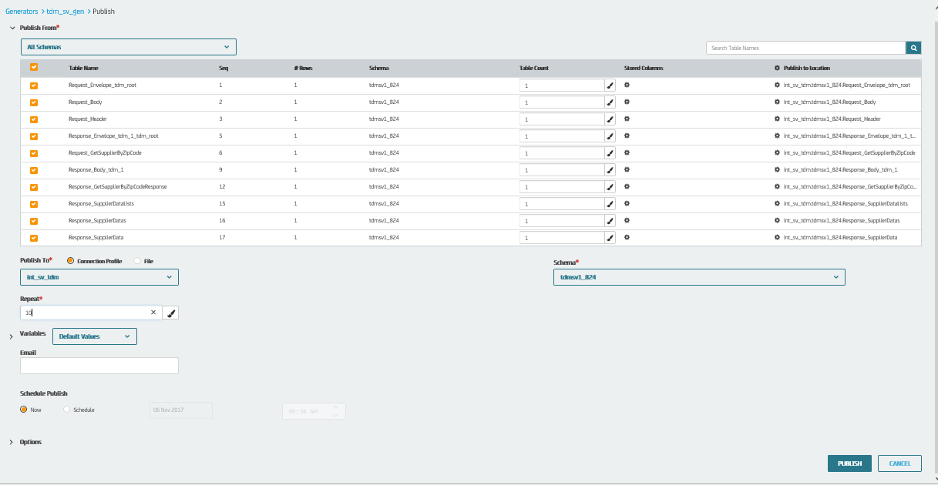

### **Step 11 : Verify Extra Records in the Database After Publishing**

Access the **Microsoft** **SQL** **Server** **database** to verify that extra rows are added to the **derived** **objects** in the **target** **database**. The same derived object now includes more records as a result of the publish process.

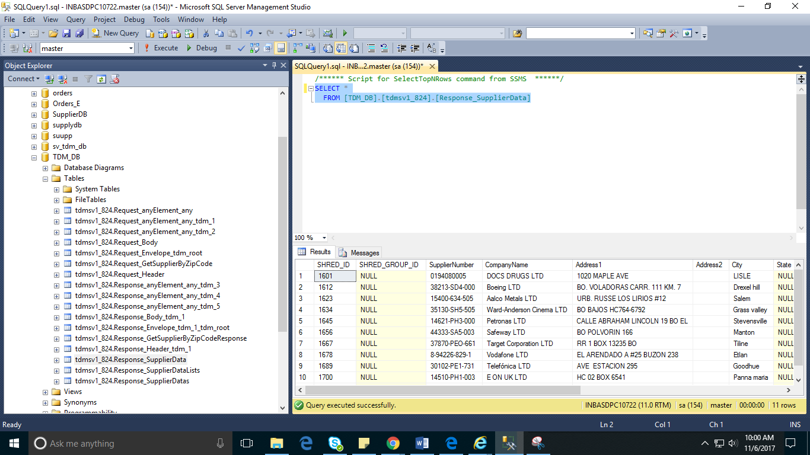

### **Step 12 : Create a Virtual Service in CA Service Virtualization**

Create a **virtual** **service** with the **initial** **sample** **RR** **pair** data that is used while **importing** **RR** **pairs** into **derived** **objects** and **deploy** them.

### **Step 13 : Configure the Virtual Service Connection in the CA TDM Portal**

To **communicate** with the required CA **Service** **Virtualization** **environment**, **configure** the CA TDM Portal with the appropriate **virtual** **service**-**related** information.

1. Click **Configuration** in the left pane.
2. Click the **DevTest Portal**option.
3. Enter information in the following fields for this example:
   * **Protocol:** Specify the protocol value to connect to the virtual service.
   * **Host Name:** Specify the name of the host where VSE is available.
   * **Port**:Specify the registry web service port number where the virtual service is running as 1505.
   * **Username:** Specify the name of the user having access to the VSE.
   * **Password:** Specify the password for the user.
4. Save the configuration details.

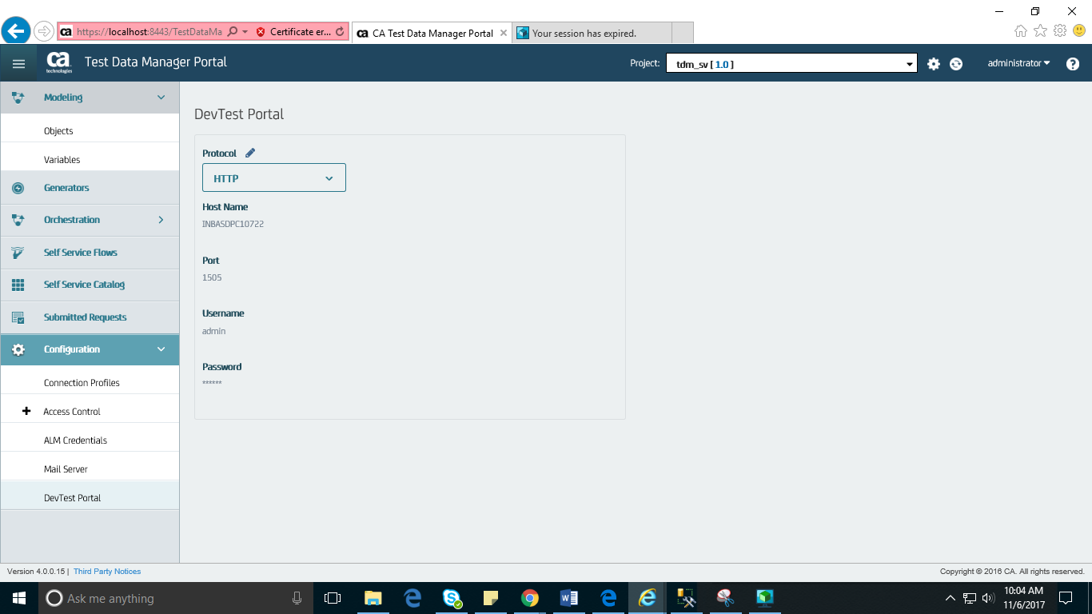

### **Step 14 : Export the Generated Data (RR Pairs) into the Virtual Service**

After you **configure** the **CA** **TDM** **Portal** to **connect** to the **virtual** **service**, you can export the **generated** **data** into the **configured** **virtual** **service**. The data is **exported** into the **virtual** **service** in the form of **XML** **RR** **pairs**.

1. In **TDM** **Portal**, click **Objects**.
2. Select the **object** to be used for the **data** **export** operation.
3. Click the Export Data icon (down arrow).
4. Enter information in the following fields for this example:
   * **Connection Profile:** Specify the connection profile name.
   * **Schema Name:** Specify the schema name.
   * **Update Virtual Service:** Select this option.
     + **Virtual Service Environment:** Specify the name of the VSE.
     + **Virtual Service:** Specify the name of the virtual service created in Workstation.
5. Click the **Export** button.

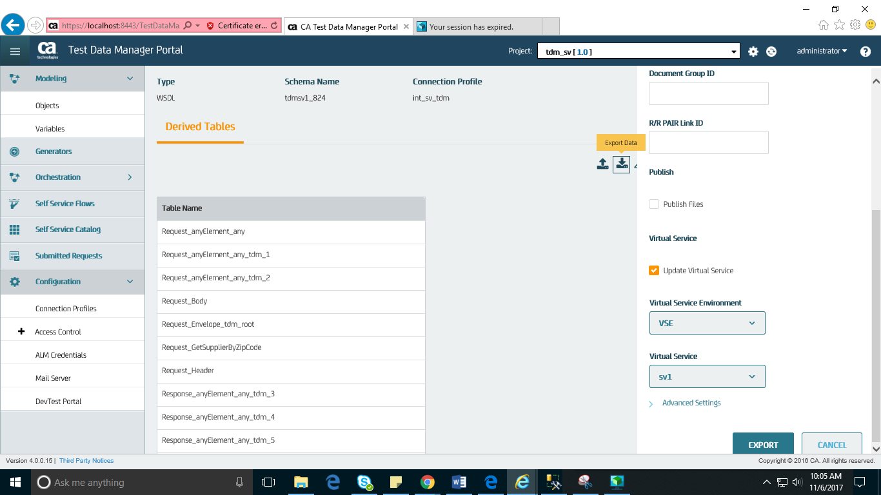

### Step 15 : **Verify the RR Pairs Added to the Virtual Service**

We can verify all the **data** **available** in the **database** is **pushed** into the **virtual** **service** in the form of **XML** **RR** **pairs**.

1. **In DevTest Workstation, Create New Test Case**.
2. Select **Add Step, Web/Web Services, Web Service Execution (XML)**.
3. Specify the **location** of the **WSDL** **file** (used for **deriving** **objects**) and the **virtual** **service** **endpoint**.
4. Paste the **request** **body** and provide the **ZIP** **code** (60532).
5. Click the **arrow** **icon** to execute the request.

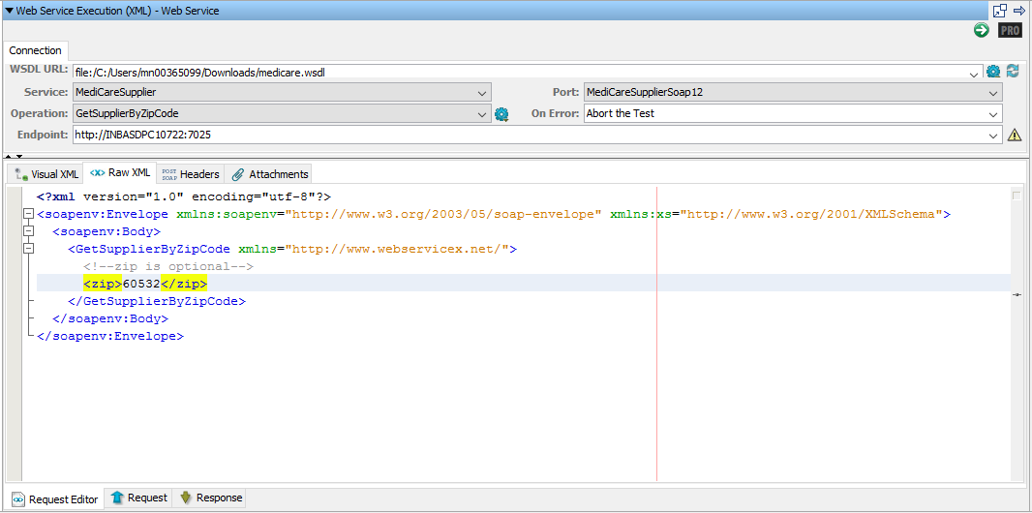

The appropriate **response** **body** is returned.

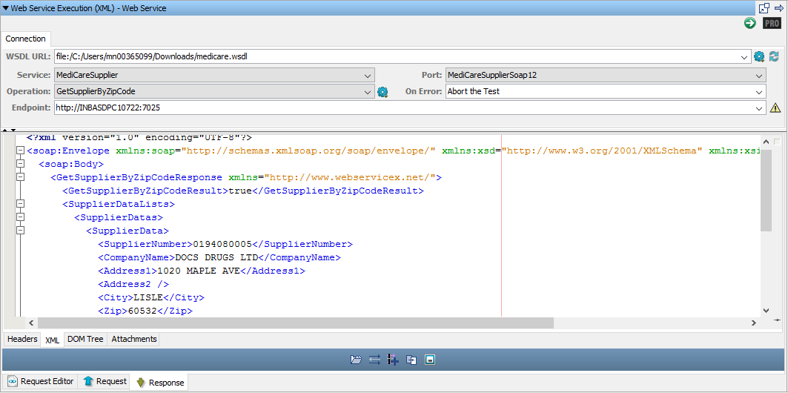

Provide the ZIP code **33407** which was added to the derived objects as a result of the data generation process. This ZIP code was not originally present in the derived objects

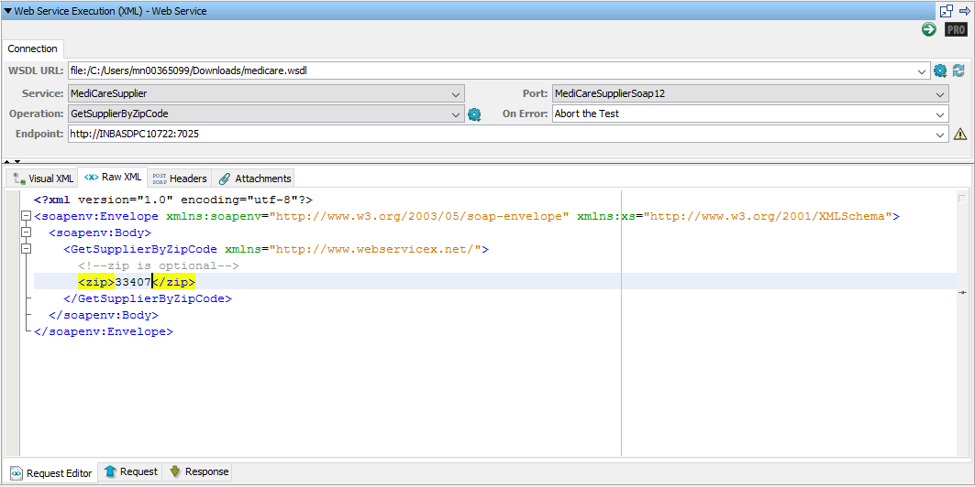

The appropriate response body is returned

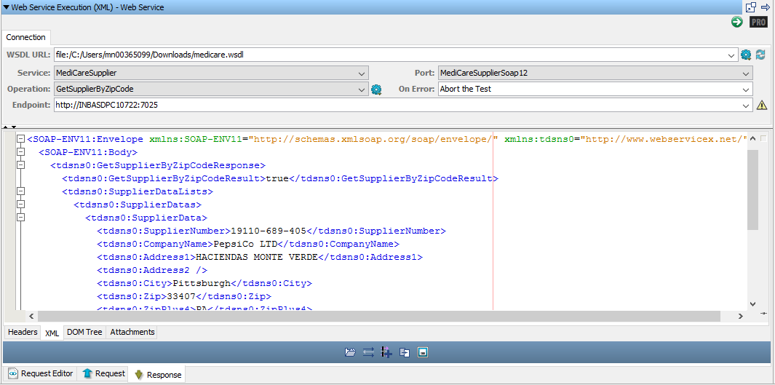

Same thing can be verified in SOAP UI as well.

Zip code: 60532

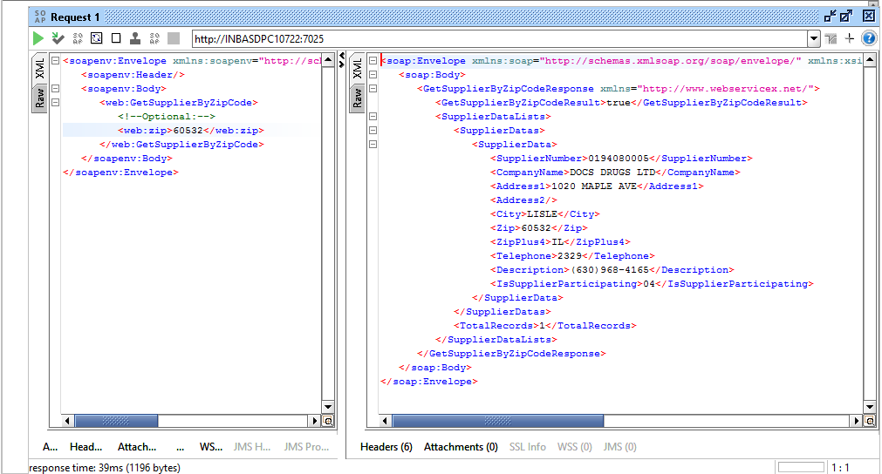

Zip code: 33407

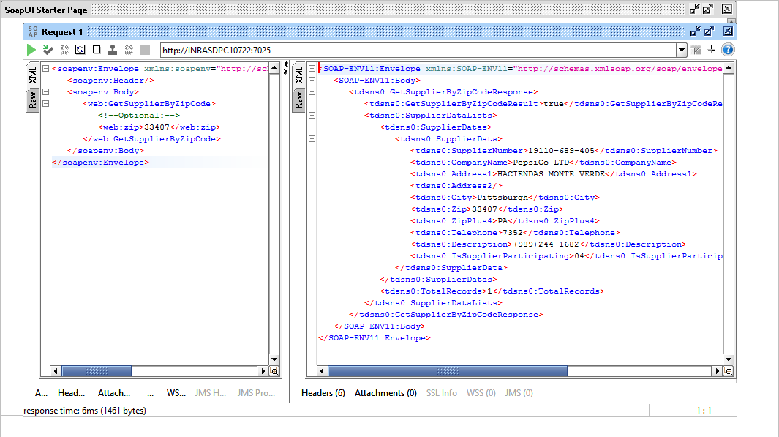

**Step 16 : New RR pairs that were exported, be available in the DevTest VSI**

1. Download the **MAR** **file** to get the generated data. Extract the MAR file.
2. Now open **Workstation** **UI**, and open the “**Project**” MAR file you just extracted.
3. Then select the **VSI**. You will see the **TDM** **generated** **data** in the response.

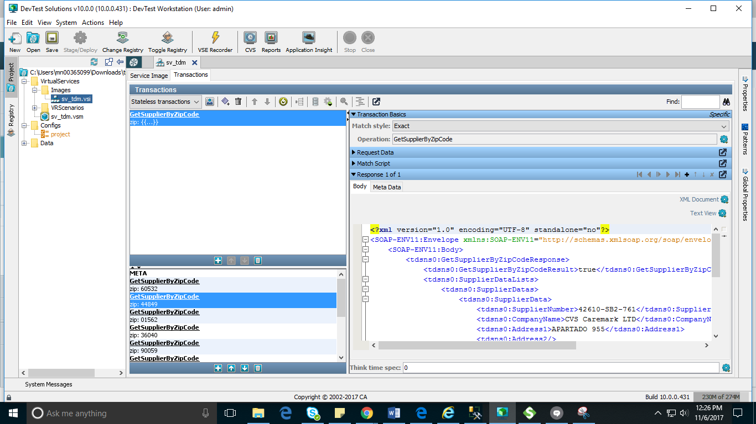

Below are the WSDL and RR pairs:

  